# Code of conduct

* When working as a team each member will respect everyone’s contribution, promote healthy discussion and ensure the contribution of each member.
* As a group we will meet twice a week at our agreed location and time; in most cases this will be the digital commons room located at the university.
* Each member should be present for each scheduled meeting and should notify the rest of the group if they are not available.
* For the storage of the group work, each member will be storing their work in a github repository which will be available to all members. Each member is advised to also store work on some form of external storage device e.g. USB, Hard-Drive as an extra contingency.
* It is each group member's responsibility to continuously back up their work to ensure data/work is up to date.
* For the most part the group will collectively come together to work on the tasks within the project to ensure an overall consistency and cohesion to the project assignment.
* Members of the group are also encouraged to work on their tasks outside of group meetings.
* While working on the tasks members of the group will log their progress and identify tasks needing to be completed for the following week.
* Each member is to refer to the project vision document to find their assigned tasks in the form of sub-systems to develop the application. They can also find the group work that is required by each member to complete collectively.
* Each member will have their assigned roles and responsibilities to the group to assist the progression of the group and can refer to Appendix 1 of this document.
* To manage the group there will be a Facebook Group chat for group discussion and scheduling and a set of meeting logs to track progress of meetings. For version control of the group work, Git will be used where members will be required to document their changes to the work via comments.
* Each week the group members have a responsibility to show up to meetings with the groups supervisor for Wednesdays at 3:30PM and will need to notify the group on whether they can attend or not.
* Group members have a responsibility to keep up to date with work and discussion if meetings have been missed.
* Group members are to avoid conflict if possible. If conflict is to arise it must be dealt with accordingly in an immediate fashion. Opinions are allowed to be challenged but in a non-aggressive way that promotes discussion rather than conflict.
* The group is to keep discussions work related at all times. If necessary steer the conversation back to the relevant topic.
* Ensure the quality of work is up to standards with what is expected by the group. Group members should be able to demonstrate their work in front of other members.
* Group members must be responsible for any hardware which is being used by the rest of the group.
* Individuals should bring up any issues or concerns that they think could affect the group, this includes both the group's work and general environment.
* The group will keep on track with the schedules and members must prioritise which work needs to be completed for deadlines are milestones. Members can refer back to project plans to monitor where they are in terms of progress for the overall project and the tasks.

**Appendix 1.**



**CODE OF CONDUCT AGREEMENT**

I have read and agree to abide by the code of conduct included on the last page of this application.

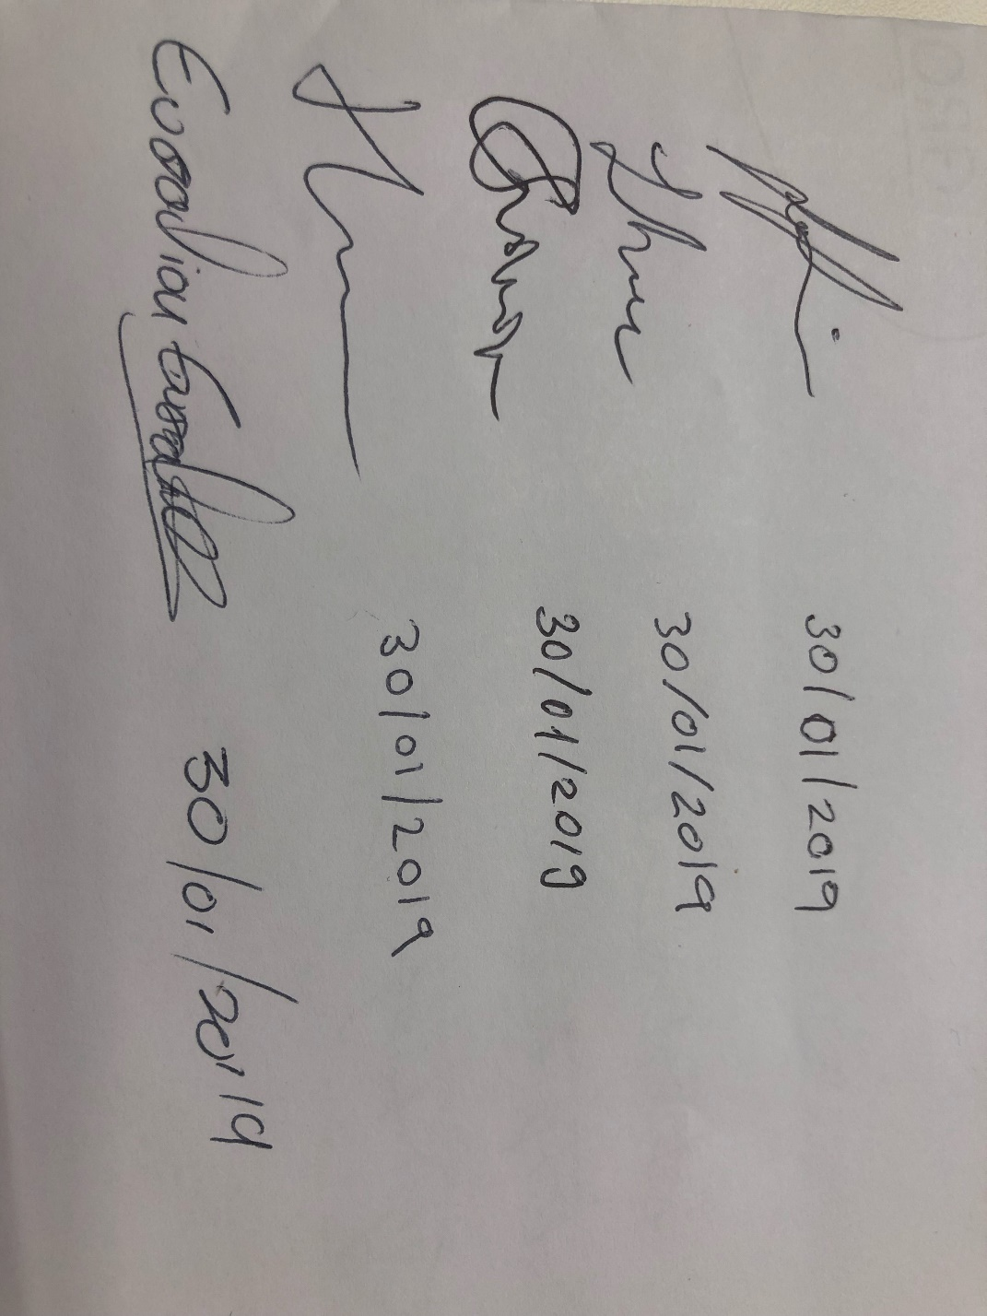___________________________________________________ __________________

Participant’s (signature) Date